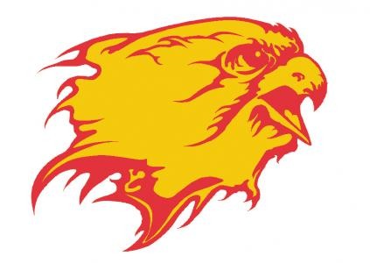
Lady Falcons Select
Girls Basketball Club
2019-2020 Team Tryouts
Tryouts will be held on:
October 13th:
5th/6th Grade*- 4-5 p.m.
7th/8th Grade – 5-6 p.m.
October 21st:
5th/6th Grade*- 6:30-7:30 p.m.
7th/8th Grade- 7:30-8:30 p.m.
*Experienced 4th graders may try out for the 5th/6th team
- Tryouts will take place in the Bishop Fenwick H.S. gymnasium. No fee to try out.
- The program has changed from previous years with all new coaches, style of play and league. The goal is to get your daughter ready to play basketball at the high school level.
- At least one 7th and 8th grade team will be fielded upon team evaluation by the BFHS and feeder team coaches. We will keep the teams to between 8 and 10 players at each level to give every player an opportunity to participate.
- A 4th/5th/6th grade team(s) will be formed based on the level of interest, with competition level to be determined by the BFHS and feeder team coaches.
- Practices will be held at Bishop Fenwick H.S. and will start in early November. Games begin in December and end the last week of February. All games will be played in the Southwest Ohio Basketball League.
- League fees, uniform fees will be dependent upon the number of participants and need for uniforms.
- Player selections will be made by BFHS coaching staff and feeder coaches.
- Anyone interested in coaching should contact Coach Brian Mahoney and include coaching experience/resume.
- Girls are encouraged to participate in the program in addition to their respective school basketball teams.
If you have any further questions, please contact:
Coach Brian Mahoney
Bishop Fenwick H.S. Coach & Lady Falcons Select Basketball Club Coordinator
bmahoney1313@yahoo.com
513-509-4342

